Nether Alderley Parish Council (PC)
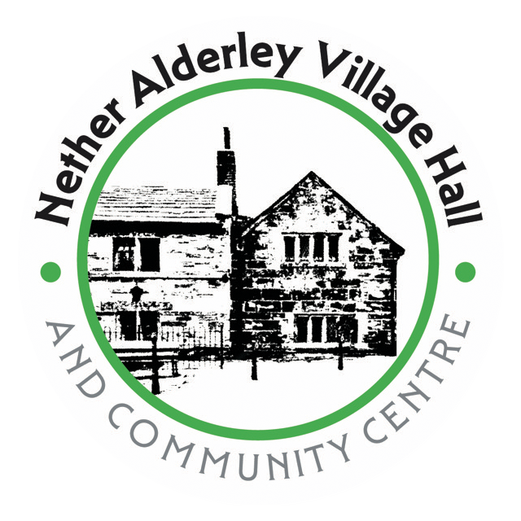

Terms and Conditions of Village Hall Hire
Booking and Payment
Minimum 2 hours hire.
Rates as per the booking form.
Single Bookings must be paid for in advance and are not confirmed until full payment is received.
Repeat Bookings are invoiced at the end of the month
Access to the hall is only allowed during the hire times and therefore any setting up and taking down time should be included in the booking and will be chargeable.
There is a I5 minute changeover period between bookings but this should no be abused.
The Hirer is liable for all damage and breakages, which must be reported to the PC/Caretaker as soon as possible following the event.
Block Bookings
The PC has introduced a `Trusted User System ` for regular users, to minimise staffing needs at events. Request to set up a block booking will be considered by the PC after the Hirers first 4 individual sessions.
Any Hirer wishing to set up a block booking following their initial 4 sessions should contact the PC to discuss the booking and payment arrangements.
However, the PC will retain the right to cancel any block booked recurring event should the hall be required on that day for a special event (a wedding or a funeral for example). If this were to happen then a minimum of 2 weeks' notice would be l be given.
Cancellations
Should the Hirer wish to cancel a booking then notification of any cancellation must be made at least one week before the event.
Should a cancellation occur up to 48 hours before the scheduled event then a cancellation fee of the full amount will be charged.
The PC can cancel any event considered to be unlawful or unsuitable or which would require any licensing conditions for which we do not have cover.

Use of the Hall
The Hirer shall only use the hall for the purposes as described in the booking form.
The Hirer must not sub hire the premises nor allow the hall to be used for any unlawful purpose.
The capacity of the hall is 100 persons standing or 70 persons seated. These numbers are a legal requirement and failure to comply with these public safety limits would invalidate our insurance and could result in legal action being taken.
The hiring arrangement with the PC is for use of the hall and the Burial Grounds and the Church grounds MUST be respected.
Church Lane and area immediately to the front of the hall must be kept clear to facilitate access for emergency vehicles.
Guests must exit onto Congleton Road via the signed one-way system
No smoking or Vaping is permitted in any part of the building or Church Grounds.
Candles, Fireworks, naked flames Chinese Lanterns and the like are not allowed in the hall or the grounds.
As previously stated, access to the hall is only allowed during the hire times and therefore if required, setting up and clearing up time must be included in the booking period.
The kitchen facilities can only be used for re-heating previously cooked food. Under no circumstances should the kitchen be used for cooking from scratch using raw ingredients.
Should the Hirer intend to use caterers for their event then they must ensure that they comply with current health and hygiene regulations.
Nether Alderley Village Hall does not have a licence to sell alcohol but a user could apply for a temporary event notice from Cheshire East Council’s Licensing Department and a licensed publican can be hired to sell alcohol on site.
Hirers may provide alcohol to guests providing they are not selling it to them and must take steps to make sure that alcoholic drinks are not available to anyone under the age of 18.
The Hirer must ensure that they nor anyone attending an event does anything to cause a nuisance to either the PC or neighbours. Should an attendee cause a nuisance it is the responsibility of the Hirer to require the person creating the nuisance to leave.

At the end of an event the Hirer must ensure that the hall is vacated at the time agreed on the booking form.
The Hall must be left in a clean and tidy condition, with any rubbish including the kitchen waste bin contents being removed. Equipment or items brought into the hall by the Hirer must be removed, and any items belonging to the PC in the hall which the Hirer has made use of must be returned to their original position.
Safety, Security and Insurance
Should an accident occur, the Hirer must report it to the Caretaker as soon as possible and record it in the relevant section of the accident book which is kept in the kitchen.
The Hirer must comply with all relevant regulations regards the safety of any electrical equipment they bring into the hall. All electrical items to be used should have been inspected and tested and the Hirer should be able to produce a current test certificate should this be requested by the PC.
The Hirer will be responsible for fire safety for the duration of the hire and will act as the `Temporary Responsible Person` This will involve the Hirer being familiar with the Fire Evacuation Procedures for the Hall , location of first aid kits and location of the
accident book.
The Fire Evacuation Procedures highlight exits and escape routes, assembly point, fire alarm locations, and contact details.
The Hirer must also ensure that access to all emergency exits is unimpeded. That fire doors are not left open or propped open at any time, and that all visitors are appraised of where the fire alarms, evacuation routes, and fire assembly points are located.
The Hirer is responsible for the security of the building upon leaving. Ensuring that all doors and windows are closed, and the building is secure.
It is the responsibility of the hirer to ensure they have appropriate insurance in place to cover them for the use of the hall and its equipment.
The hire by a person or group running a commercial operation will be required to provide evidence of public liability insurance indemnifying the PC from and against all costs, claims, losses, damage or proceedings arising from any death, accident, injury or damage to any person whatsoever which may arise out of or in consequence of the use of the premises (except insofar as resulting from any act or neglect done or committed during the period of hire by the PC and/or its employees).

For an individual hiring the Hall on a none commercial basis the Parish Council carries Hirers liability insurance to cover the above issues on behalf of the hirer. However, the property of the hirer is not covered under the hall`s insurance and the hirer should arrange their own insurance for any valuable items brought into the hall.
If the hirer is running a non-commercial event but engages the services of a person(s) who operate on a commercial basis, then the hirer must ensure that the provider has their own public liability cover.

